Complete Student Microservices deployment — EC2 to Amazon EKS
Step 1 — Create the EC2 instance
Choose the AWS region Europe (Stockholm) — eu-north-1, then select Launch instance.
Setting | Enter/select
Name | student-server
Operating system | Ubuntu Server 24.04 LTS
Architecture | 64-bit x86
Instance type | m7i-flex.large
Key pair | student-key-cicd.pem (or your existing key)
Root storage | 40 GiB gp3
Network | VPC with internet access
Auto-assign public IP | Enable
Security group | Create new: student-management-sg
Inbound rule | SSH TCP 22, Source: My IP
Step 2 — Create and attach the EC2 IAM role
- Open IAM → Roles → Create role.
- Choose AWS service → EC2.
- Attach permissions required for your Terraform EKS configuration : select administrator role for simple way (optional way including IAM, EC2/VPC, EKS, and any S3 state backend resources.)
- Name the role student-terraform-management-role.
- Go to EC2 → Instances → student-server → Actions → Security → Modify IAM role, and select the new role.
Add In bound Rules in student-management-sg Security Group:
For application Access: Custom TCP 8080 MyIP
For Argo CD: Cutom TCP 8081 MyIP
For Grafana : Custom TCP 3000 MYIP
For Prometheus Custom TCP 9090 MYIP
For Alert Mnaager Custom TCP 9093 MYIP

Connect from Git Bash
ssh -i ~/Downloads/student-key.pem \
ubuntu@YOUR_EC2_PUBLIC_IP
sudo hostnamectl set-hostname student-server
exec bash
Install essential Ubuntu packages
sudo apt update
sudo apt upgrade -y
sudo apt install -y \
git curl wget unzip jq \
python3 python3-pip \
gnupg ca-certificates lsb-release
git --version
python3 --version
Install Terraform
wget -O- https://apt.releases.hashicorp.com/gpg \
| sudo gpg --dearmor \
-o /usr/share/keyrings/hashicorp-archive-keyring.gpg
echo "deb [arch=$(dpkg --print-architecture) signed-by=/usr/share/keyrings/hashicorp-archive-keyring.gpg] https://apt.releases.hashicorp.com $(. /etc/os-release && echo "$VERSION_CODENAME") main" \
| sudo tee /etc/apt/sources.list.d/hashicorp.list
sudo apt update
sudo apt install -y terraform

terraform version
Install AWS CLI v2
curl -fsSL \
https://awscli.amazonaws.com/awscli-exe-linux-x86_64.zip \
-o awscliv2.zip
unzip -q awscliv2.zip
sudo ./aws/install
aws --version
Verify your IAM instance role:
aws sts get-caller-identity
# AWS cluster Region change region according to your cluster location
aws configure set region eu-north-1

aws configure get region
Install kubectl
curl -fL \
https://s3.us-west-2.amazonaws.com/amazon-eks/1.34.9/2026-07-05/bin/linux/amd64/kubectl \
-o kubectl
chmod +x kubectl
sudo mv kubectl /usr/local/bin/kubectl
kubectl version --client
Install Helm
curl -fsSLO \
https://raw.githubusercontent.com/helm/helm/main/scripts/get-helm-3
chmod 700 get-helm-3
./get-helm-3
helm version
Clone the repository:
git clone \
https://github.com/harathi-mutyam/micro_svc_student_app_cicd.git
cd micro_svc_student_app_cicd
git status --short
git branch --show-current
ls -la
check any syntax errors in shell scripts
chmod +x scripts/*.sh
for file in scripts/*.sh database/init.sh; do
bash -n "$file" || exit 1
done
change admin_cidr with your ec2 instance public ip
cd ~/micro_svc_student_app_cicd
vim terraform/terraform.tfvars
change admin_cidr with your # EC2 Public IP for administrative access
Example: admin_cidr = "16.170.165.24/32"
Save it
Before push the changes to git hub repository create a classic Token for you repository
Create GitHub Personal Access Token (Classic)
- Open GitHub click on right side top coner on your profile picturesettings Devoloper settings Personal access tokens Tokens(classic)Click Generate new token.-->Select Generate new token (classic). Enter a Note: Student-App-GitHub-ActionsSelect expiration (e.g. 90 days) Select REPO check box and WorkFlow checkbox Click on Generate Token copy the Token value and save it some where.It will use to push anything into your repository
git pull origin main
git status
git add terraform/terraform.tfvars
git commit -m "Update terraform.tfvars file admin cicr with ec2"
git config --global user.email ehmutyam@example.com
git config --global user.name harathi-mutyam
git push origin main
enter
Username for 'https://github.com': harathi-mutyam
Password for 'https://harathi-mutyam@github.com':
git status
Step 3: Configure GitHub Actions to publish Docker images
Code available in ci.yml file
create GitHub variables and secrets for Dockerhub user
Before pushing ci.yml, configure the following at Github Actions Variables and secrets
Secret | Required value
DOCKERHUB_TOKEN | Docker Hub access token with push permissions

Create docker hub username as a variable
DOCKERHUB_USERNAME : harathi2026

Steps to create a dockerhub token login to docker hub click on profile on right side cornerselect account settings select personal access tokens name: student-microsvc-token ,Expiration : 30 days , Access Permissions: Repo Read & Write generate a token save the token and place it in a github as a secret
Check it in browser: open project github repositoryactionsrunner Build successful

Open server gitbash terminal
cd ~/micro_svc_student_app_cicd
git pull --ff-only origin main
export DOCKERHUB_USERNAME="harathi2026"
export IMAGE_TAG="$(git rev-parse HEAD)"
echo "$IMAGE_TAG"
echo "${#IMAGE_TAG}"
Create A Cluster through Terraform
cd terraform
terraform init
terraform validate
terraform plan -out=tfplan
terraform show tfplan
terraform apply tfplan
Connect to EKS
#region must match claster provided region
aws eks update-kubeconfig \
--region eu-north-1 \
--name student-cluster
kubectl get nodes -o wide
ctrl+c
check nodes are ready or not
Check EBS CSI addon:
aws eks describe-addon \
--cluster-name student-cluster \
--region eu-north-1 \
--addon-name aws-ebs-csi-driver \
--query 'addon.status' \
--output text
Output must be ACTIVE

Create Secrets and ConfigMaps
Only after EKS and its EBS CSI driver are ready:
cd ~/micro_svc_student_app_cicd
# Generate environment configuration file (.env.k8s)
bash scripts/01-prepare-env.sh
# Apply namespaces, secrets, and configmaps
bash scripts/02-apply-prerequisites.sh
Verify resources:
kubectl get secret student-secrets -n student-app
kubectl get configmaps -n student-app
OutPut: You should see student-secrets (with 13 keys) and ConfigMaps mysql-init and nginx-config.

Deploy Microservices Applications
Export your Docker Hub credentials and deploy all microservices in order:
Bash
# Export deployment variables
export DOCKERHUB_USERNAME="harathi2026"
go to docker hub copy the latest image tag
export IMAGE_TAG="paste the copied image tag here"
or optional way
export IMAGE_TAG="$(git rev-parse HEAD)"

echo "Username: $DOCKERHUB_USERNAME"
echo "Image Tag: $IMAGE_TAG"

# Run deployment script
bash scripts/03-deploy-in-order.sh
Verify Pods and Persistent Storage:
kubectl -n student-app get pods -w
(Press Ctrl + C once database-0, auth, students, attendance, marks, frontend, and gateway are running)
# Check database persistent volume claim
kubectl -n student-app get pvc
Verification: data-database-0 status should be Bound.
Step : Access and Test Application in Browser
Start port-forwarding for the API gateway:
open one more new git bash terminal
ssh -i ~/Downloads/student-key.pem ubuntu@YOUR_EC2_PUBLIC_IP
sudo hostnamectl set-hostname student-application-test
exec bash

kubectl port-forward -n student-app svc/gateway 8080:80 \
--address=0.0.0.0
(Keep this terminal open and running)
Retrieve admin password (in a old server Git Bash terminal):
grep '^DEMO_ADMIN_PASSWORD=' ~/micro_svc_student_app_cicd/.env.k8s
copy the password
Open browser and test the application is running or not
http://<YOUR_EC2_PUBLIC_IP>:8080
Username: admin
Password: (Value copied from .env.k8s)
Click on login
Phase 2 — Argo CD GitOps deployment
Step : Install and Configure Argo CD
# Create namespace and install Argo CD
kubectl create namespace argocd
kubectl get namespace argocd
kubectl apply -n argocd --server-side \
-f https://raw.githubusercontent.com/argoproj/argo-cd/stable/manifests/install.yaml

Verify: optional commands
kubectl get pods -n argocd
kubectl get deployments -n argocd
kubectl get statefulsets -n argocd
kubectl get services -n argocd

# Wait for Argo CD server to be ready
kubectl rollout status deployment/argocd-server \
-n argocd --timeout=300s
# Retrieve initial admin password
kubectl get secret argocd-initial-admin-secret -n argocd \
-o jsonpath='{.data.password}' | base64 -d; echo
Save the password
Step : Access the Argo Cd Dashboard
Open another Gitbash Terminal
Login through ssh
ssh -i ~/Downloads/student-key-cicd.pem ubuntu@server_public_ip

sudo hostnamectl set-hostname argocd
exec bash

kubectl port-forward -n argocd svc/argocd-server \
--address=0.0.0.0 8081:443

Open Windows Browser :
http://server_ec2_publicip:8081
username : admin
Password: paste argo cd initial admin password

Observe it argo cd dash board created
Step :Apply Argo CD Application manifest:
cd ~/micro_svc_student_app_cicd
kubectl apply -f argocd/student-app-argocd.yaml
# Check application sync state
kubectl get applications -n argocd
NAME SYNC STATUS HEALTH STATUS
student-app Synced Healthy
Look for SYNC STATUS: Synced and HEALTH STATUS: Healthy.
Open argo dashboard in browser and check there also.
Phase 3 — Monitoring Student Microservices on Amazon EKS
Check memore space
cd ~/micro_svc_student_app_cicd
kubectl describe nodes | grep -A 8 "Allocated resources:"
Create monitoring directory and namespace
kubectl create namespace monitoring \
--dry-run=client -o yaml | kubectl apply -f -
kubectl get namespace monitoring
Add Prometheus Helm repository
helm repo add prometheus-community \
https://prometheus-community.github.io/helm-charts
helm repo update
verify:
helm search repo prometheus-community/kube-prometheus-stack
helm list -n monitoring
check monitoring values file
cat monitoring/prometheus-values.yaml
helm list -n monitoring
ubuntu@student-server:~/micro_svc_student_app_cicd$ helm list -n monitoring
NAME NAMESPACE REVISION UPDATED STATUS CHART APP VERSION

Now render the Helm chart:
helm template kube-prometheus-stack \
prometheus-community/kube-prometheus-stack \
--version 92.17.1 \
--namespace monitoring \
-f monitoring/prometheus-values.yaml \
> /tmp/student-monitoring-rendered.yaml
Verify:
test -s /tmp/student-monitoring-rendered.yaml \
&& echo "PASS: Helm template rendering successful"
helm show chart \
prometheus-community/kube-prometheus-stack \
--version 92.17.1

Install Prometheus and Grafana
helm upgrade --install kube-prometheus-stack \
prometheus-community/kube-prometheus-stack \
--version 92.17.1 \
--namespace monitoring \
-f monitoring/prometheus-values.yaml \
--wait \
--timeout 15m
Verify the installation (PVC added in grafana for dashboards persistence purpose)
kubectl get pvc -n monitoring
Check STATUS: Bound
kubectl get pods -n monitoring -l "app.kubernetes.io/name=grafana"
helm list -n monitoring
kubectl get pods -n monitoring
kubectl get deployments -n monitoring
kubectl get statefulsets -n monitoring
kubectl get daemonsets -n monitoring
kubectl get svc -n monitoring
Verify Prometheus:
kubectl get prometheus -n monitoring
If a monitoring Pod is Pending
Run:
kubectl get pods -n monitoring
kubectl get events -n monitoring \
--sort-by=.lastTimestamp
If all pods are running continue this step
Get Grafana administrator password
kubectl get secret -n monitoring \
kube-prometheus-stack-grafana

kubectl get secret kube-prometheus-stack-grafana \
-n monitoring \
-o jsonpath='{.data.admin-password}' | base64 -d

Echo
Save the password
Step : Access Grafana Dashbord through Browser
open one more gitbash terminal for grafana
ssh -i ~/Downloads/student-key-cicd.pem ubuntu@server_public_ip
sudo hostnamectl set-hostname Grafana
exec bash
kubectl port-forward \
-n monitoring \
svc/kube-prometheus-stack-grafana \
3000:80 --address=0.0.0.0
Forwarding from 127.0.0.1:3000 -> 80
Forwarding from [::1]:3000 -> 80

Open Grafana in Broser http://<Server-ec2-public-ip>:3000
username:admin
password:paste saved one here login
Check your Kubernetes dashboards
Inside Grafana:
- Select Dashboards from the left navigation.
- Look for the Kubernetes dashboards installed by kube-prometheus-stack.
- Open Kubernetes / Compute Resources / Cluster.
- Review CPU utilization, memory utilization, and Pod resource usage.
- select the Namespace dropdown in dashboard and select student-app (where the namespace variable is available.)

Click on dash boards Kubernetes / Compute Resources / Namespace (Pods) inside select namespace: student-app (on top)

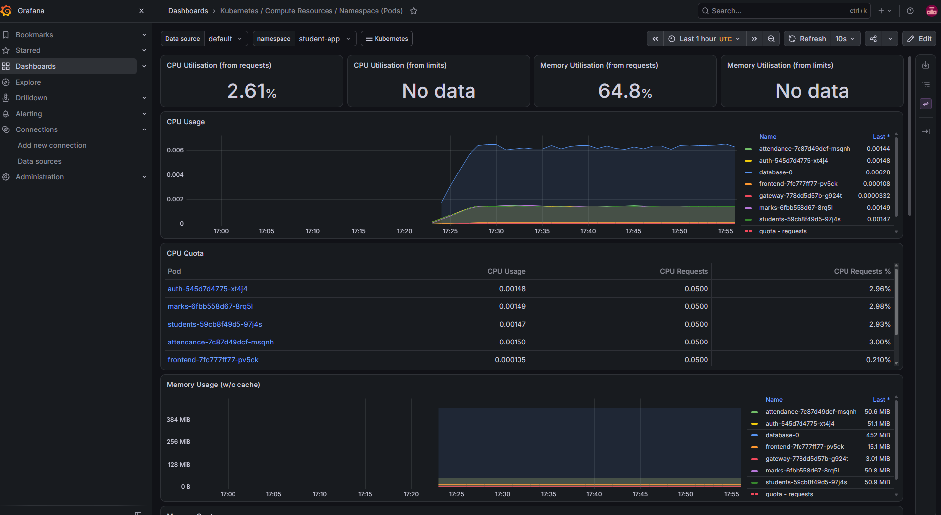
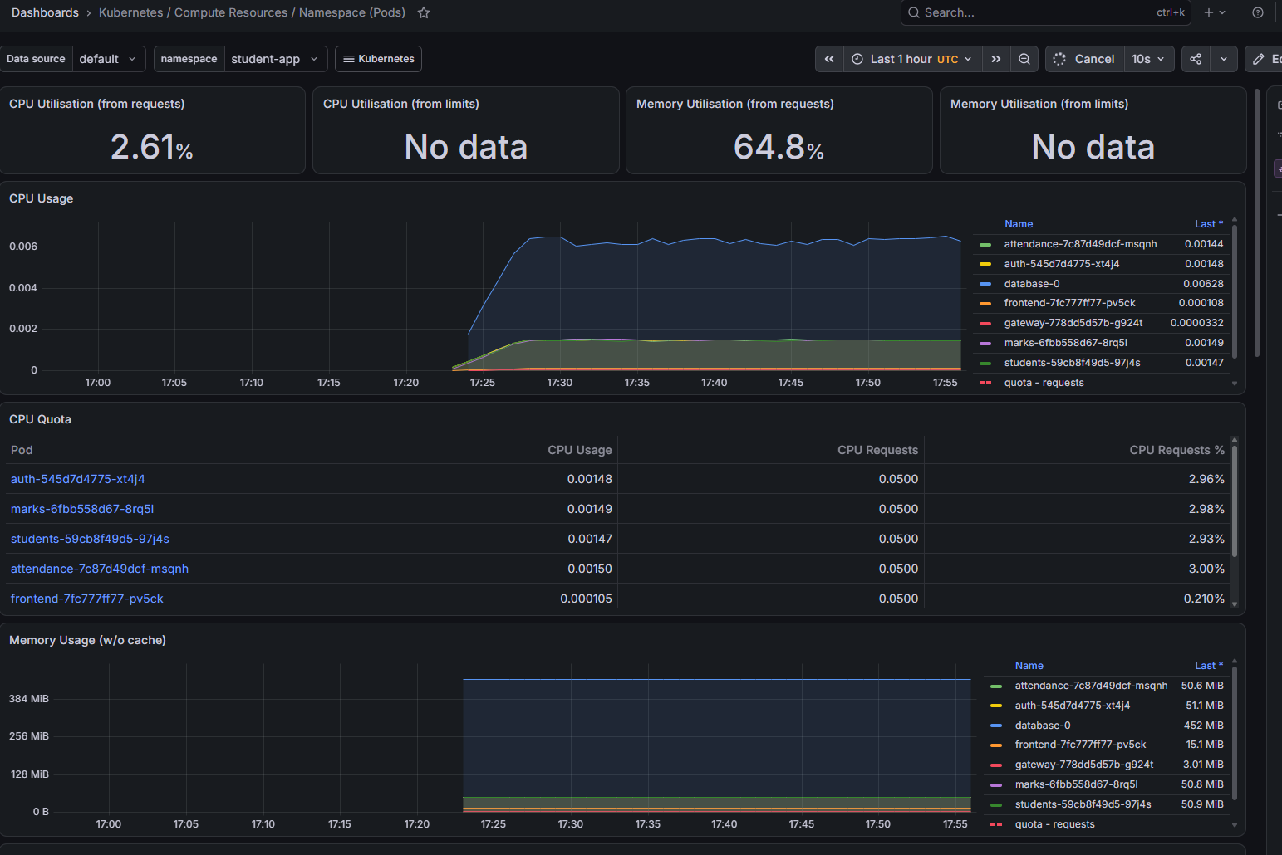
Dashboards Kubernetes / Compute Resources / Namespace (Workloads)select namespace: student-app
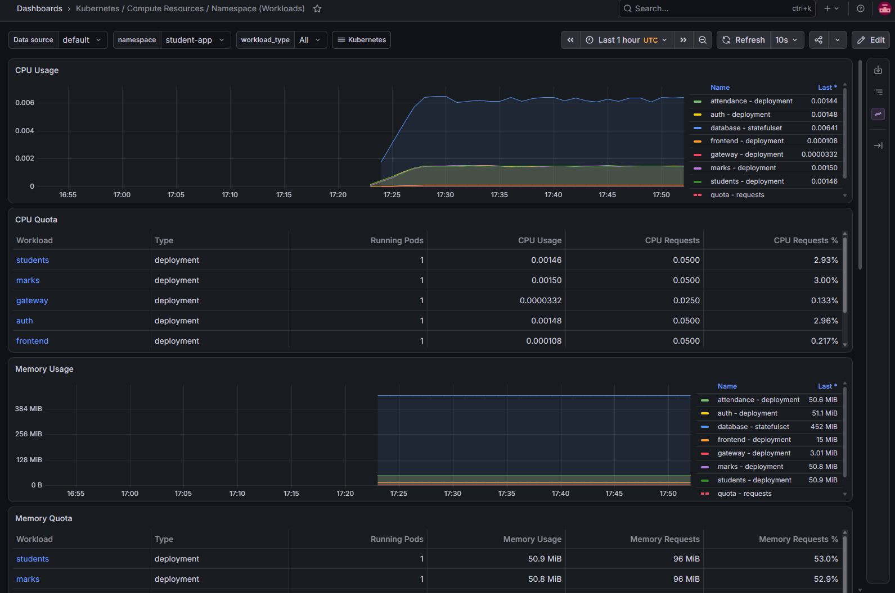
Navigate to Memory QuotaClick on student or marks or any service
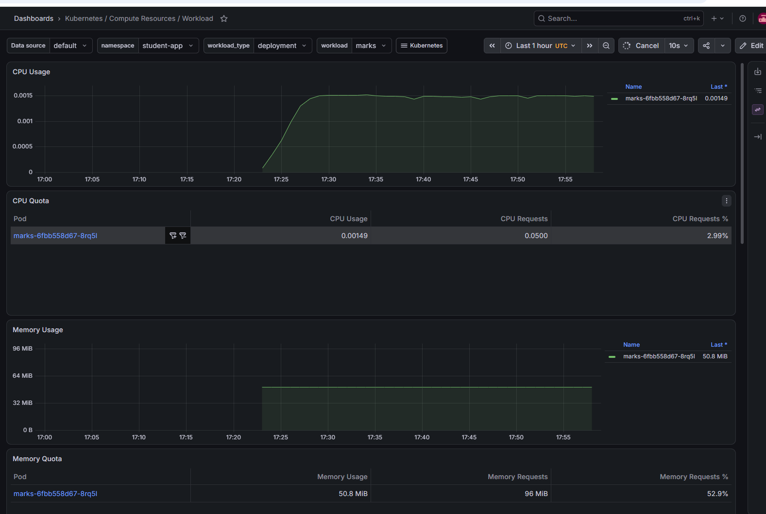
Dashboards Kubernetes / Compute Resources / Namespace (Workloads)select namespace: argocd

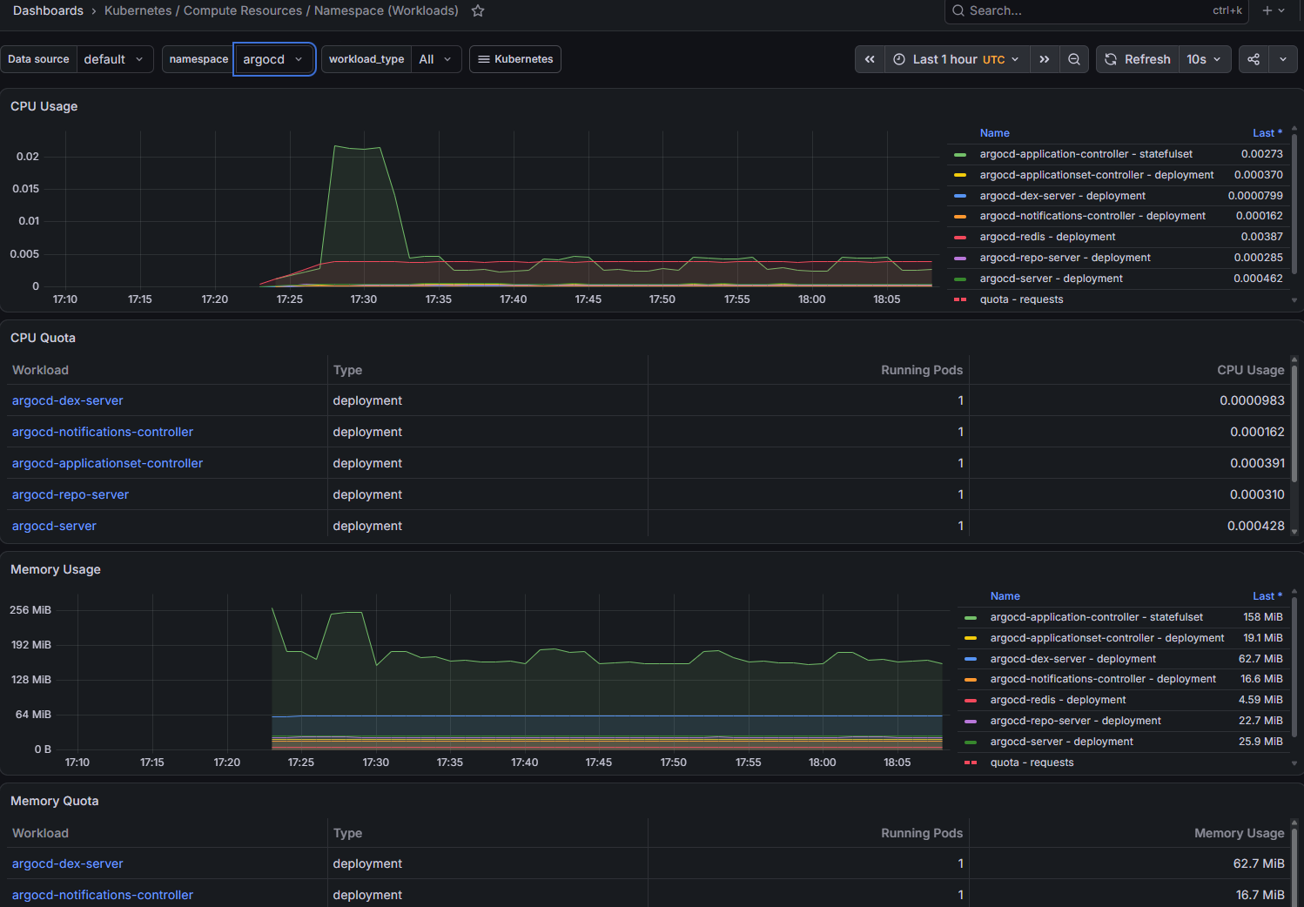
Dashboards Kubernetes / Compute Resources / Namespace (Workloads)select namespace: monitoring

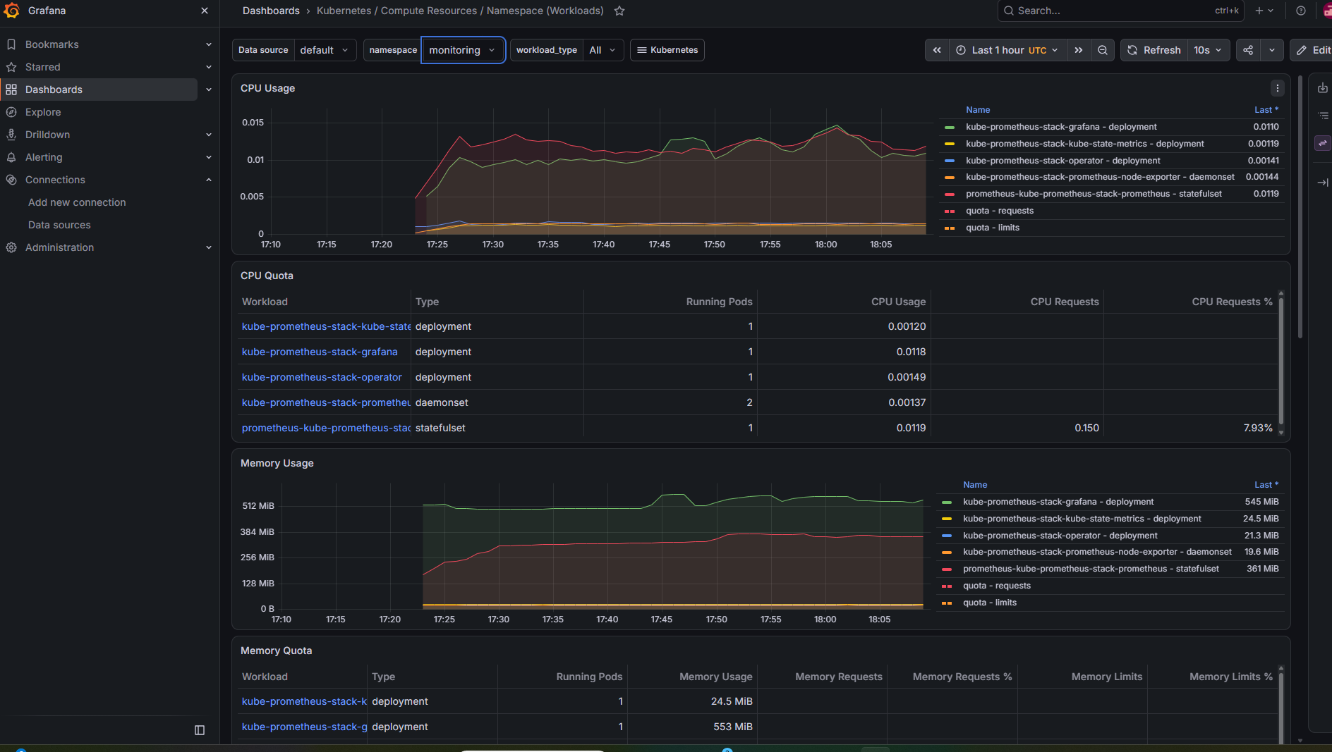

Verify metrics directly in Grafana
Navigate to Explore, select the Prometheus data source on right side select code and run this PromQL expression: up click on Run Query
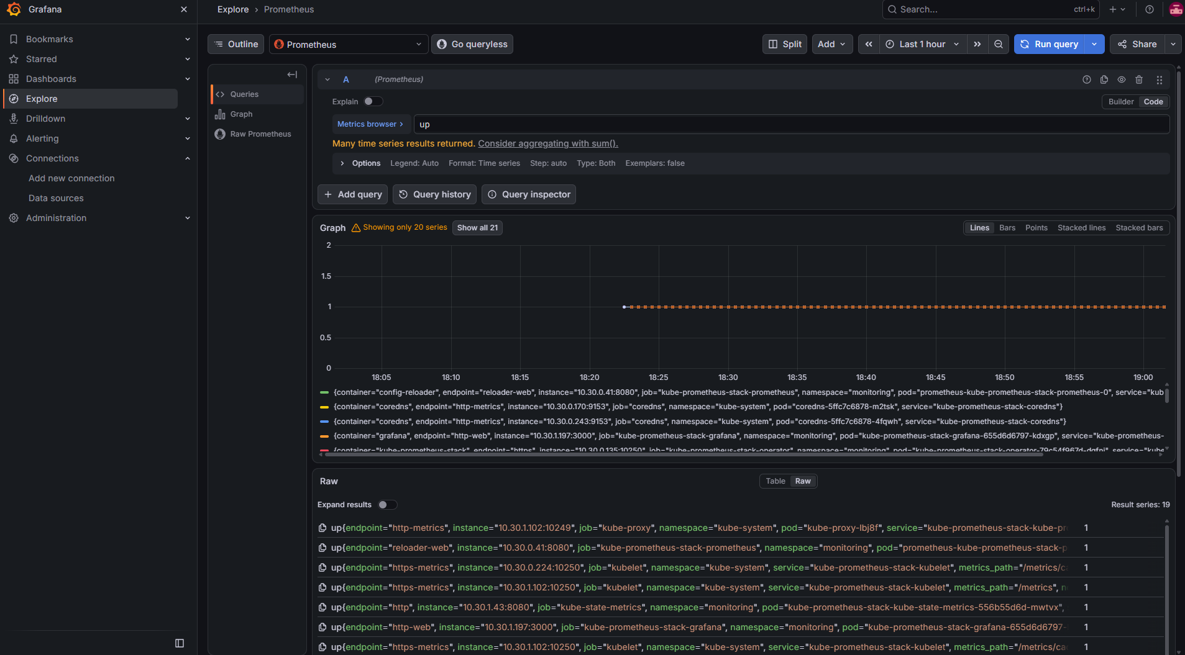
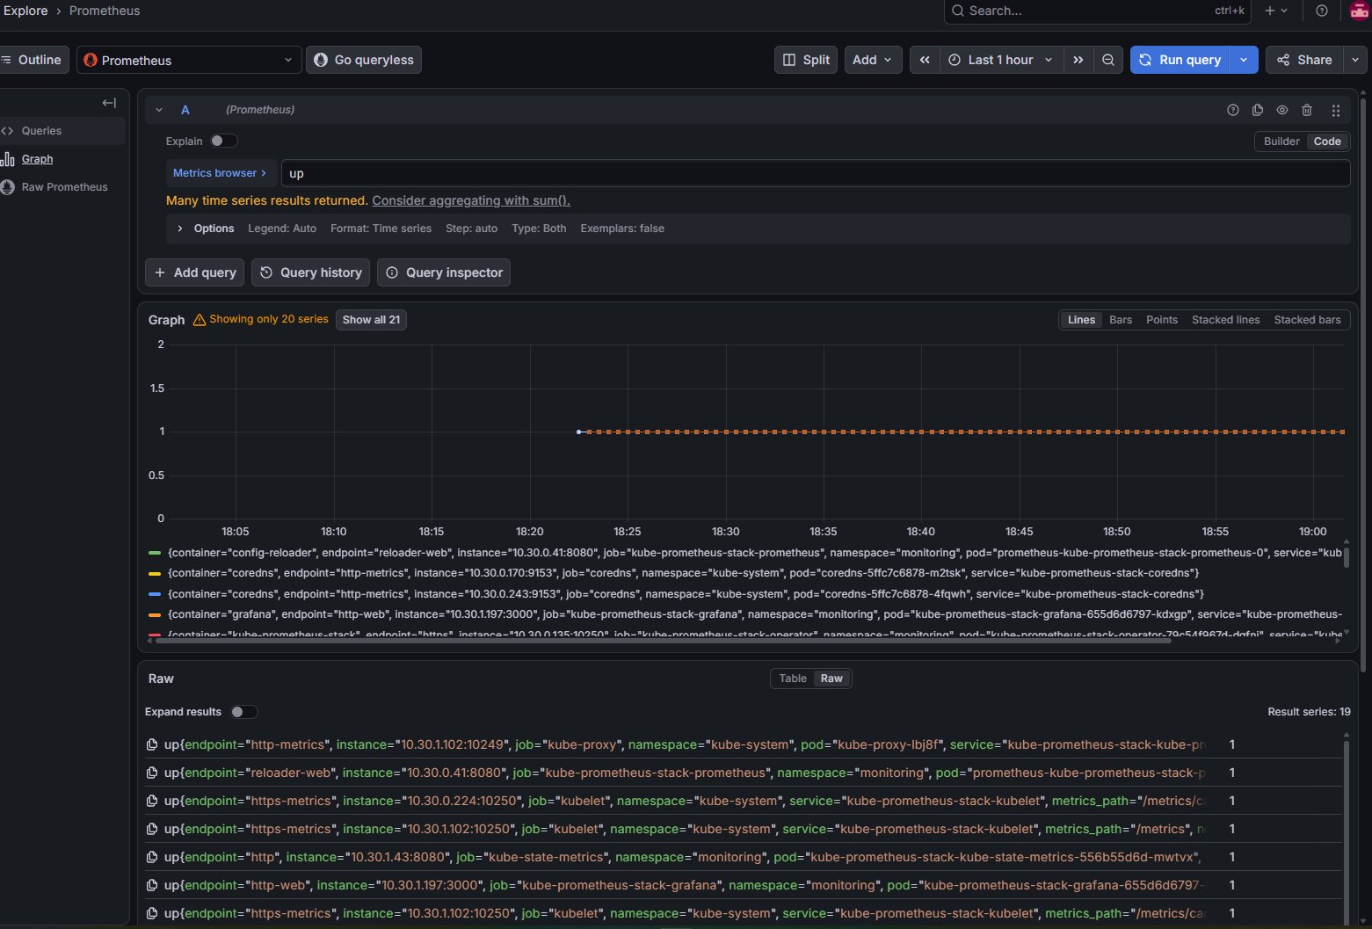
Next, query your Student application Pods:
kube_pod_status_phase{
namespace="student-app",
phase="Running"
}

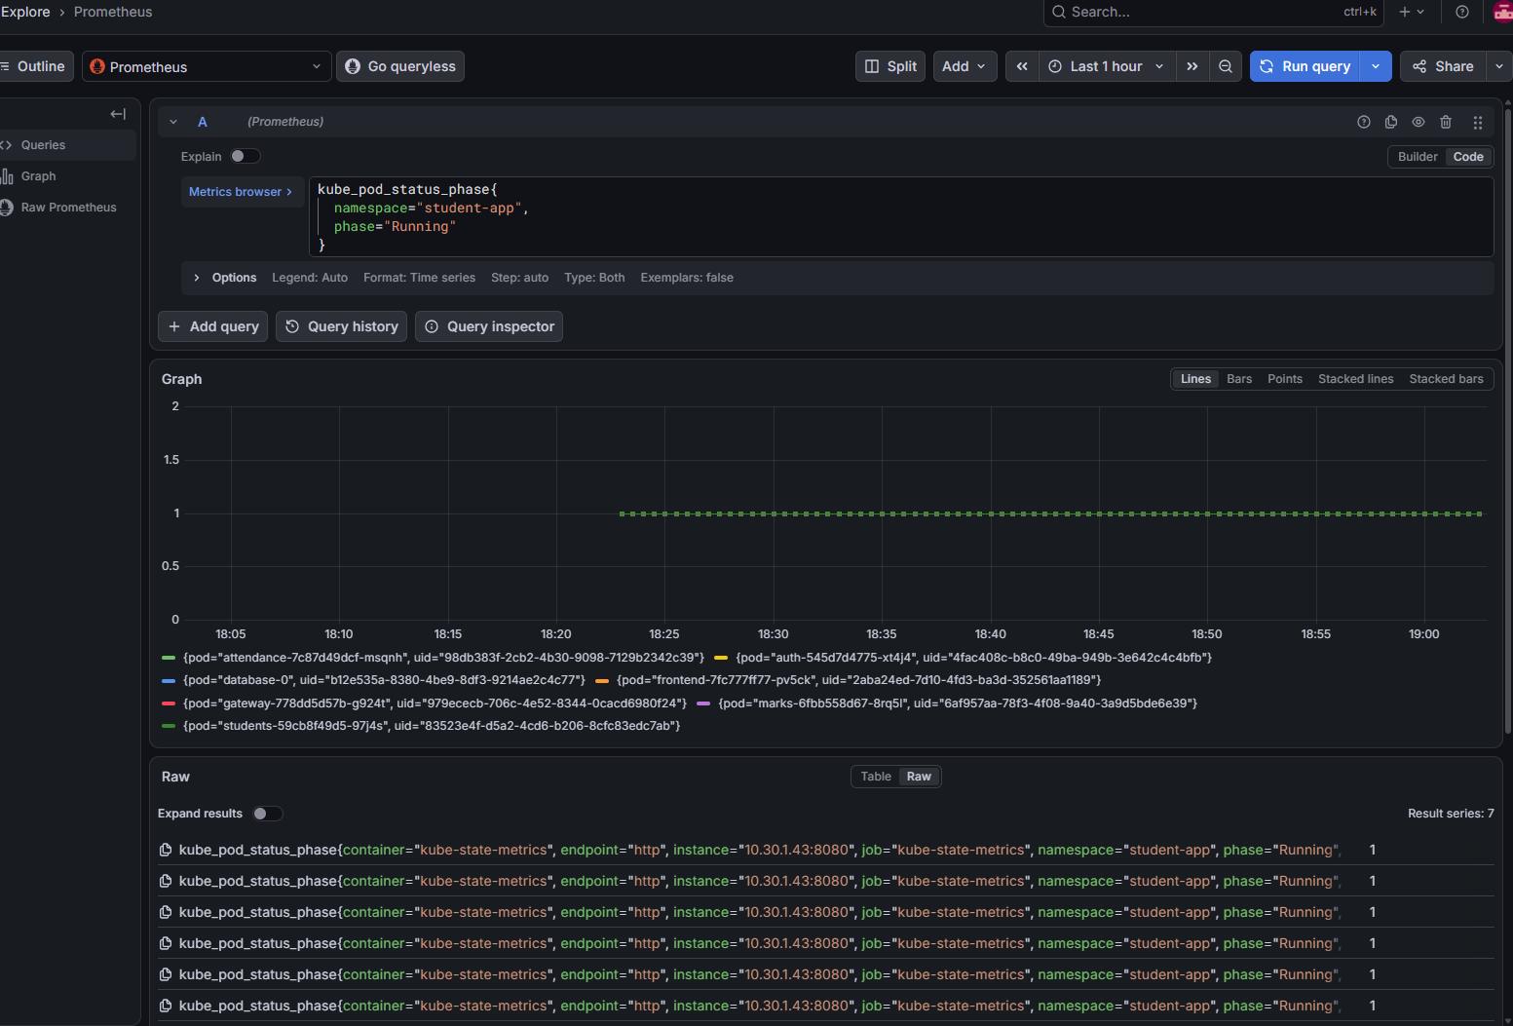
For container CPU usage:
sum by (pod) (
rate(
container_cpu_usage_seconds_total{
namespace="student-app",
container!="",
container!="POD"
}[5m]
)
)

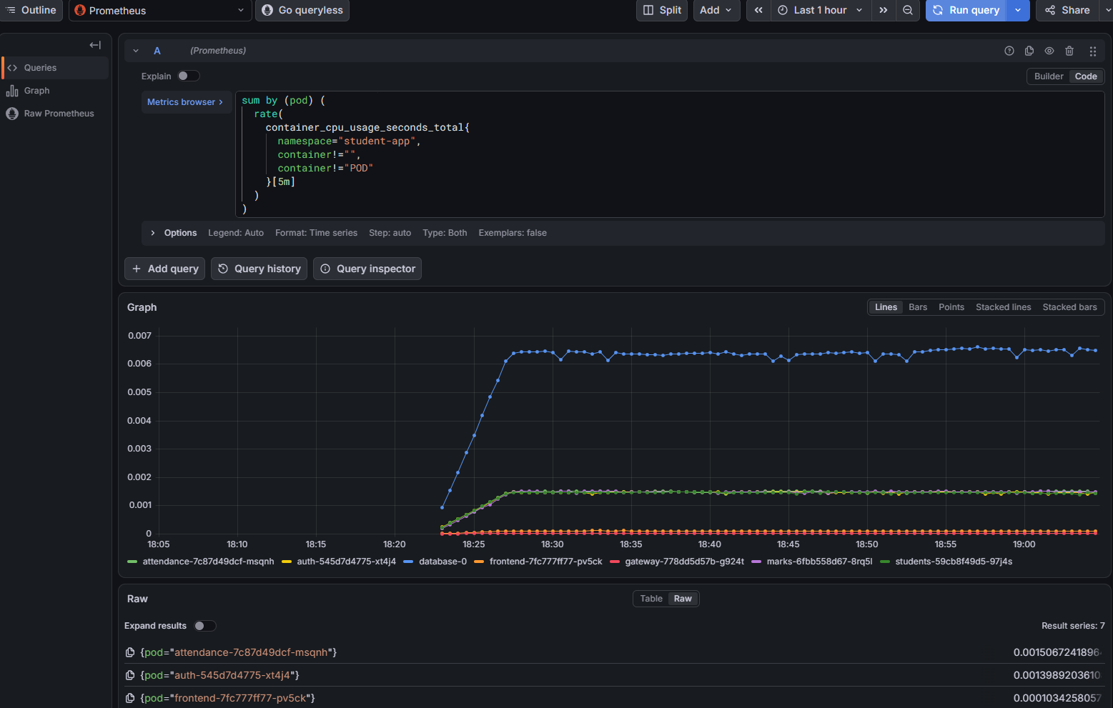
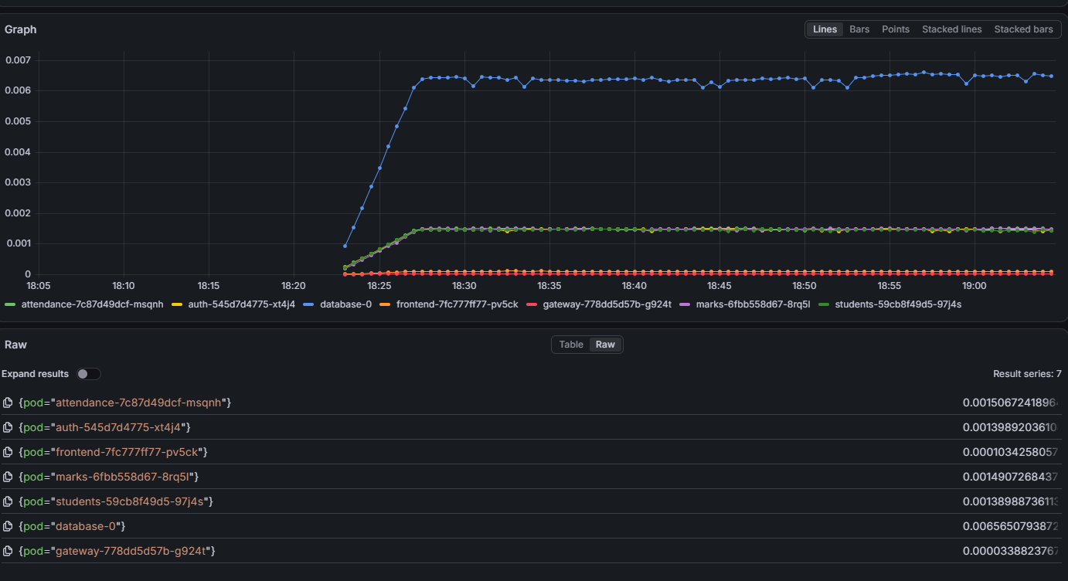
Delete the old Query and enter
For container memory:
sum by (pod) (
container_memory_working_set_bytes{
namespace="student-app",
container!="",
container!="POD"
}
)
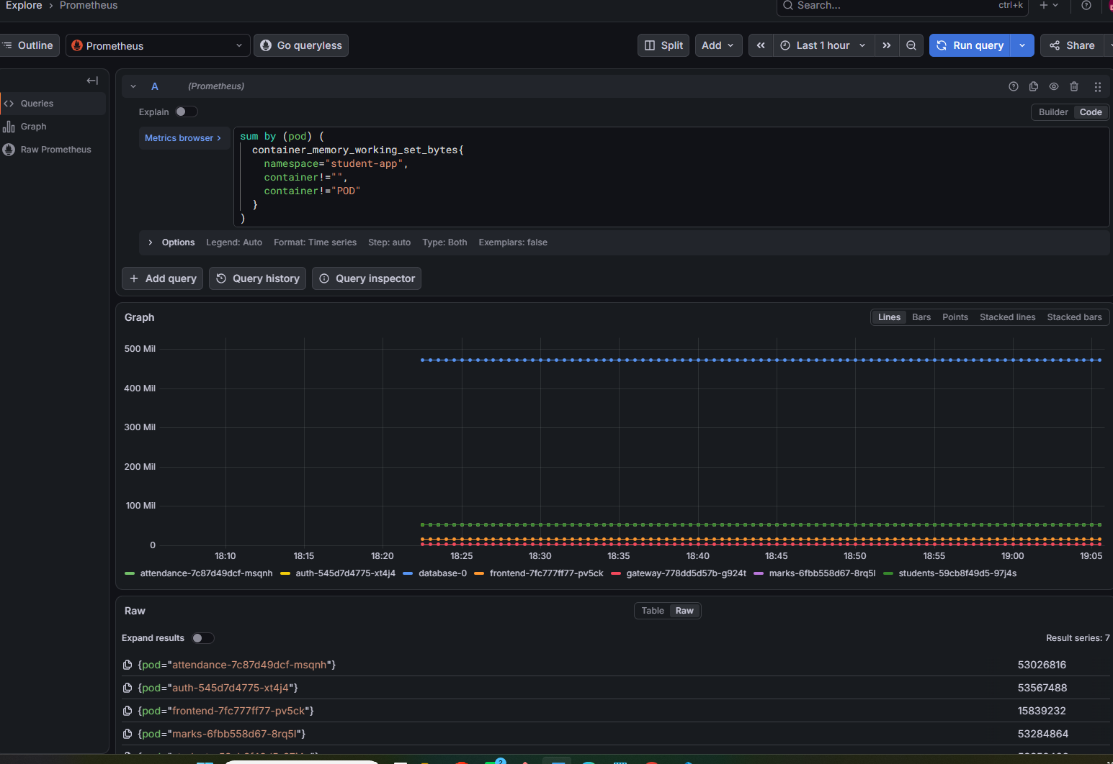
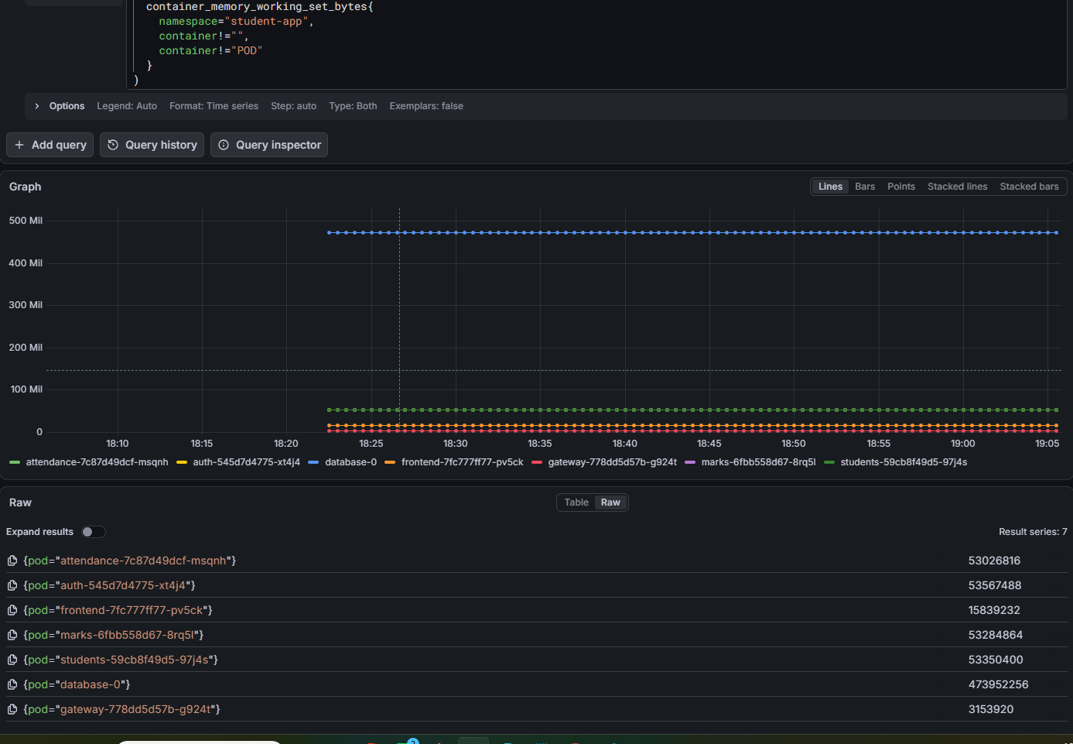
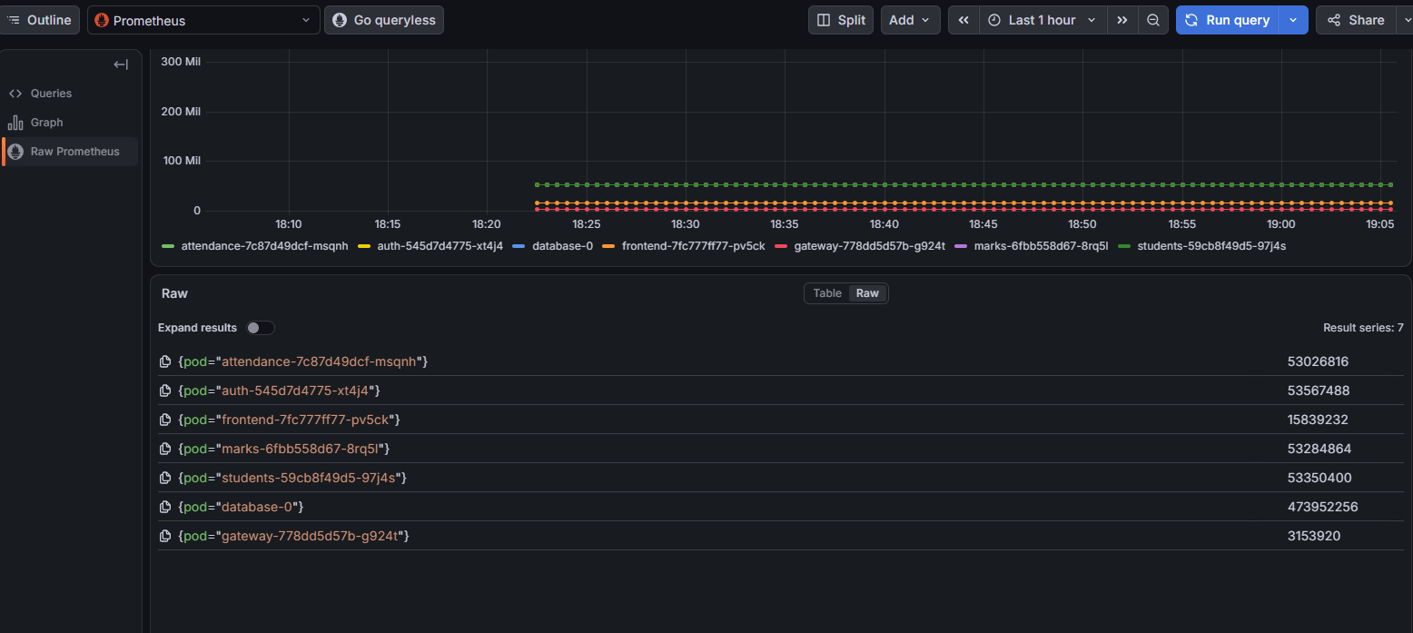

Create a Dashboard for application in Grafana in 2 ways either manual way or through json
Method 1: Build Panels Manually in Grafana UI
- Create a New Dashboard:
  - Open Grafana at http://<YOUR_EC2_PUBLIC_IP>:3000.
  - Click the + (plus icon) in the top-right corner or left menu, and select New Dashboard.
  - Click + Add visualization.
  - Select prometheus (or kube-prometheus-stack-prometheus) as the data source.
  - Verification: A new panel configuration screen appears with a query editor at the bottom.
- Panel 1: Running Pods Status (Stat Panel):
  - PromQL Query:
Code-Snippet
sum(kube_pod_status_phase{namespace="student-app", phase="Running"})
  - On the right-hand panel settings, change the visualization type from Time series to Stat.
  - Under Panel options, set Title to Healthy Running Pods.
  - Click Apply in the top right.
  - Verification: The panel displays a numeric count of your running pods (e.g., 7).
- Panel 2: CPU Utilization by Microservice (Time Series):
  - Click + Add -> Visualization.
  - PromQL Query:
Code-Snippet
sum by (pod) (rate(container_cpu_usage_seconds_total{namespace="student-app", container!="", container!="POD"}[5m]))
  - Under Legend, set the label format to {{pod}}.
  - Set Title to CPU Usage per Pod (Cores).
  - Under Standard options -> Unit, choose Data Rate / Throughput or type cores.
  - Click Apply.
  - Verification: A multi-line graph displays CPU usage curves for each service.
- Panel 3: Memory Usage by Microservice (Time Series):
  - Click + Add -> Visualization.
  - PromQL Query:
Code-Snippet
sum by (pod) (container_memory_working_set_bytes{namespace="student-app", container!="", container!="POD"})
  - Under Legend, enter {{pod}}.
  - Set Title to Memory Working Set (RAM).
  - Under Standard options -> Unit, select Data (IEC) -> Bytes (IEC) or Megabytes (MiB).
  - Click Apply.
  - Verification: Graphs show real-time memory usage (e.g., ~120 MiB for database-0).
- Panel 4: Network Ingress/Egress Throughput:
  - Click + Add -> Visualization.
  - Query A (Received):
Code-Snippet
sum by (pod) (rate(container_network_receive_bytes_total{namespace="student-app"}[5m]))
Legend: {{pod}} - Ingress
  - Query B (Transmitted):
Code-Snippet
sum by (pod) (rate(container_network_transmit_bytes_total{namespace="student-app"}[5m]))
Legend: {{pod}} - Egress
  - Under Standard options -> Unit, select Data Rate -> Bytes/sec.
  - Set Title to Pod Network Traffic (Bytes/sec).
  - Click Apply.
  - Verification: Traffic throughput graphs show up when requests are sent through the gateway.
- Save Your Dashboard:
  - Click the Disk icon (Save dashboard) in the top-right toolbar.
  - Enter the name Student Microservices Overview and click Save.
  - Verification: The dashboard title updates to "Student Microservices Overview" and persists upon page refresh.
Method 2: Import via Ready-to-Use Dashboard JSON
Import a pre-configured dashboard using the JSON model to instantly set up all panels.
1. Retrieve the Dashboard JSON
- From your server terminal:
cat monitoring/grafana-dashboard.json

Copy the entire terminal output.

- Or directly from GitHub: Navigate to https://github.com/harathi-mutyam/micro_svc_student_app_cicd/blob/main/monitoring/grafana-dashboard.json
in your project repository, click Raw, and copy the text.
2. Import into Grafana
- In Grafana, click Dashboards in the left sidebar.
- Click New -> Import.
- Under Import via panel json, paste the copied JSON text.
Click Load. Click import
For verification:
go to Dash Boardsselect Student Microservices Application Dashboardand confirm all metric panels are streaming data.
Step :To observe live Spikes in Grafana

Open server gitbash terminal run these commands
for i in {1..200}; do
curl -s http://127.0.0.1:8080/api/auth/health > /dev/null
curl -s http://127.0.0.1:8080/api/students/health > /dev/null
curl -s http://127.0.0.1:8080/api/attendance/health > /dev/null
curl -s http://127.0.0.1:8080/api/marks/health > /dev/null
done
echo "Traffic test complete: 800 total HTTP requests sent."

Open Grafana Dashboard in browser http://<YOUR_EC2_PUBLIC_IP>:3000
In the top-right corner:
- Change the time range to Last 5 minutes or Last 15 minutes.
- Set the auto-refresh interval to 5s (next to the Refresh button).
Check the panels:
- Network Ingress (Received): Sharp spikes will appear for gateway, auth, students, attendance, and marks.
- CPU Usage per Pod: Microservice CPU utilization lines will spike upwards during the burst.

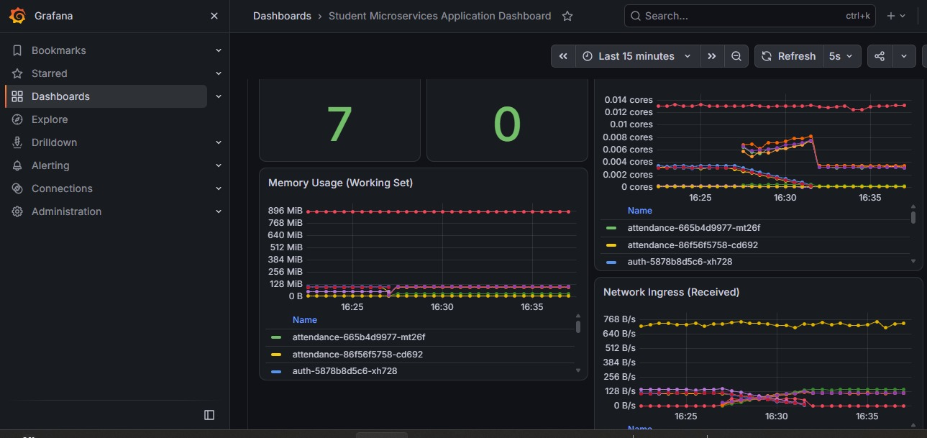

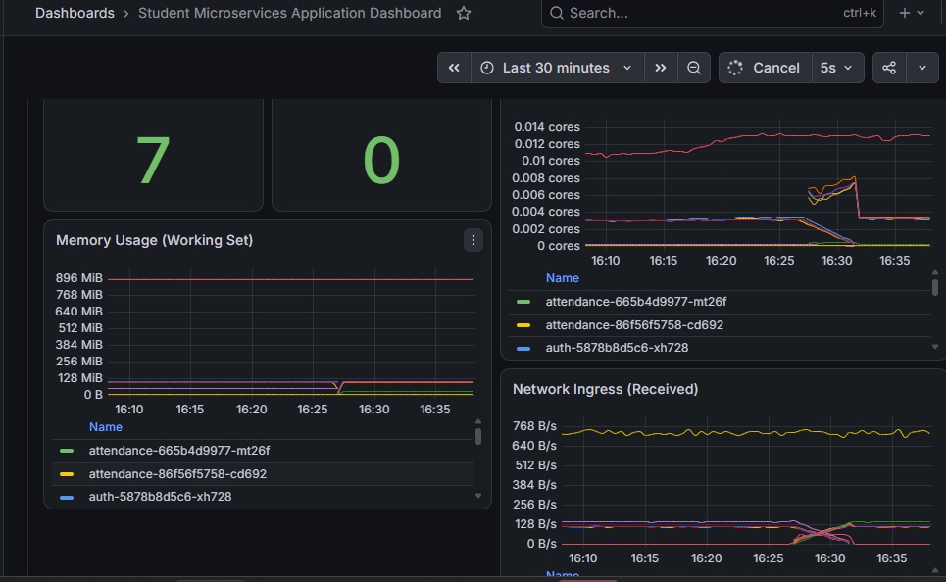

Phase 4: Loki and Grafana Alloy
Open server gitbash terminal
#Check memory space
kubectl describe nodes | grep -E "DiskPressure|Allocated resources" -A 8

helm repo add grafana https://grafana.github.io/helm-charts
helm repo update

cd ~/micro_svc_student_app_cicd
export AWS_REGION="us-east-1"
export CLUSTER_NAME="student-cluster"
export ACCOUNT_ID=$(aws sts get-caller-identity --query Account --output text)
export LOKI_CHUNKS_BUCKET="student-loki-chunks-${ACCOUNT_ID}-${AWS_REGION}"
export LOKI_RULER_BUCKET="student-loki-ruler-${ACCOUNT_ID}-${AWS_REGION}"
echo "Account: $ACCOUNT_ID | Cluster: $CLUSTER_NAME | Region: $AWS_REGION"
echo "Chunks Bucket: $LOKI_CHUNKS_BUCKET"
echo "Ruler Bucket: $LOKI_RULER_BUCKET"

Create the S3 buckets
aws s3api create-bucket --bucket "$LOKI_CHUNKS_BUCKET" --region "$AWS_REGION"
aws s3api create-bucket --bucket "$LOKI_RULER_BUCKET" --region "$AWS_REGION"

for BUCKET in "$LOKI_CHUNKS_BUCKET" "$LOKI_RULER_BUCKET"; do
aws s3api put-public-access-block \
--bucket "$BUCKET" \
--public-access-block-configuration \
BlockPublicAcls=true,IgnorePublicAcls=true,BlockPublicPolicy=true,RestrictPublicBuckets=true

aws s3api put-bucket-encryption \
--bucket "$BUCKET" \
--server-side-encryption-configuration \
'{"Rules":[{"ApplyServerSideEncryptionByDefault":{"SSEAlgorithm":"AES256"}}]}'
Done

aws s3 ls | grep student-loki
Install eksctl & Configure IAM Roles for Service Accounts (IRSA)
Install eksctl
if ! command -v eksctl &> /dev/null; then
curl -sLO "https://github.com/eksctl-io/eksctl/releases/latest/download/eksctl_Linux_amd64.tar.gz"
tar -xzf eksctl_Linux_amd64.tar.gz
sudo install -m 0755 eksctl /usr/local/bin/eksctl
rm -f eksctl eksctl_Linux_amd64.tar.gz
fi

eksctl version
Associate OIDC Provider with your EKS cluster:
eksctl utils associate-iam-oidc-provider --cluster "$CLUSTER_NAME" \
--region "$AWS_REGION" --approve
Create the IAM Policy for S3 access
Using this file to create a policy or run manual way
chmod +x ./scripts/create-loki-s3-policy.sh

./scripts/create-loki-s3-policy.sh \
"$LOKI_CHUNKS_BUCKET" \
"$LOKI_RULER_BUCKET"

Create the logging namespace & ServiceAccount
Check IAM created Policy
aws iam list-policies \
--scope Local \
--query "Policies[?PolicyName=='StudentLokiS3Policy'].[PolicyName,Arn]" \
--output table
kubectl create namespace logging --dry-run=client -o yaml | kubectl apply -f -

eksctl create iamserviceaccount \
--cluster "$CLUSTER_NAME" \
--region "$AWS_REGION" \
--namespace logging \
--name loki \
--role-name StudentLokiS3Role \
--attach-policy-arn "arn:aws:iam::${ACCOUNT_ID}:policy/StudentLokiS3Policy" \
--override-existing-serviceaccounts \
--approve
Verify:
kubectl get sa loki -n logging -o yaml
Configure and Deploy Loki with S3 Backend
Add the Grafana Community Helm repository
helm repo add grafana-community \
https://grafana-community.github.io/helm-charts

helm repo update
Generate logging/loki-values.yaml
cat logging/loki-values.yaml
Deploy Loki
helm upgrade --install loki grafana-community/loki \
--version 19.0.3 \
--namespace logging \
-f logging/loki-values.yaml \
--wait \
--timeout 10m

kubectl get pods -n logging
NAME READY STATUS RESTARTS AGE
loki-0 2/2 Running 0 90s
loki-canary-hhh9q 1/1 Running 0 90s
loki-canary-qlhpv 1/1 Running 0 90s
loki-gateway-9847cdff6-dsgv9 2/2 Running 0 90s

Install Grafana Alloy to Ship Pod Logs
Add the official Grafana Helm repository:
helm repo add grafana https://grafana.github.io/helm-charts
helm repo update
Create or Verify logging/alloy-values.yaml
cat logging/alloy-values.yaml
Deploy Alloy as a DaemonSet
helm upgrade --install alloy grafana/alloy \
--version 1.14.1 \
--namespace logging \
-f logging/alloy-values.yaml \
--wait \
--timeout 10m
kubectl get ds -n logging
NAME DESIRED CURRENT READY UP-TO-DATE AVAILABLE NODE SELECTOR AGE
alloy 2 2 2 2 2 <none> 86s
loki-canary 2 2 2 2 2 <none> 7m3s

Step : Connect Loki to Grafana
Open Grafana in your web browser http://<YOUR_EC2_PUBLIC_IP>:3000
Go to Connections -> Data sources -> click Add data source.
Select Loki.
In the Connection URL field, enter:
http://loki-gateway.logging.svc.cluster.local/
Scroll down and click Save & test.
Query Application Logs in Grafana Explore
Navigate to Explore select Loki select Code mode paste the {namespace="student-app"} click on Run query
With Explanation:
- Click Explore (compass icon) in Grafana's left navigation sidebar.
- Select Loki from the top data source dropdown.
- Switch to Code mode and test your Student Microservices queries
All Student Microservices Logs:
{namespace="student-app"}
Specific Service Logs (e.g., Auth or Students):
{namespace="student-app", app="auth"}
{namespace="student-app", app="students"}
MySQL Database Logs:
{namespace="student-app", app="database"}
Search for errors:
{namespace="student-app"} |= "error"
Step : Add a Live Logs Panel to Your Existing Dashboard

- Open your Student Microservices Application Dashboard in Grafana.
- Click Add -> Visualization (top toolbar).
- Select data source Loki.
- Enter the query: {namespace="student-app"}
- On the right-hand settings panel, change visualization type to Logs.
- Set the Panel Title to Student Microservices - Live Logs
- Click Apply in the top right, then click the Save disk icon.
Same way check for marks also and add visulisation
{namespace="student-app", app="students"}
Verification: The panel displays auto-refreshing log streams directly beneath your existing CPU, RAM, and Network metrics panels.
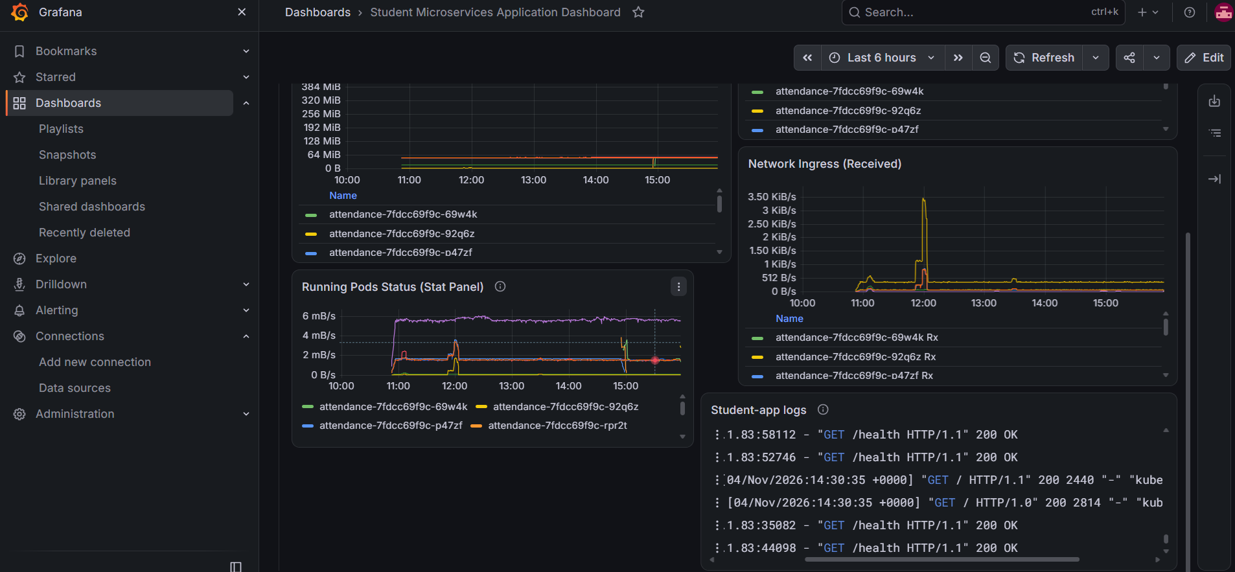

Phase 5: Verify AWS S3 Log Persistence
Open aws console open s3 open chunks bucketcheck logs are present or not

Generate traffic to trigger write logs
Open server gitbash terminal
for i in {1..30}; do
curl -s http://127.0.0.1:8080/api/auth/health > /dev/null
curl -s http://127.0.0.1:8080/api/students/health > /dev/null
done
open Grafana dash board in browserchange Refresh time to 5 seconds
observe the logs are refreshing now
# Inspect chunks stored in S3 through gitbahs terminal
Open server gitbash Terminal
aws s3 ls "s3://${LOKI_CHUNKS_BUCKET}/" --recursive --summarize
Phase 6: Alertmanager Setup & Student App Alerting Rules

Verify Alertmanager Is Running

kubectl get pods -n monitoring \
-l "app.kubernetes.io/name=alertmanager"

kubectl get svc -n monitoring \
-l "app.kubernetes.io/name=alertmanager"

NAME READY STATUS RESTARTS AGE
alertmanager-kube-prometheus-stack-alertmanager-0 2/2 Running 0
Create Custom Prometheus Alert Rules for student-app
Created a Kubernetes PrometheusRule Custom Resource Definition (CRD) that tells Prometheus when to trigger alerts for pod down events, high CPU usage, crash loops, and database connectivity failures.
cat monitoring/student-app-alerts.yaml
kubectl apply -f monitoring/student-app-alerts.yaml
Step : Verify the Alert Rules in Prometheus UI
Port-forward the Prometheus server:
Open one more git bash terminal login through ssh
ssh -i ~/Downloads/student-key-cicd.pem ubuntu@3.80.204.112
sudo hostnamectl set-hostname Prometheus-alertmanager
exec bash
kubectl port-forward -n monitoring \
svc/kube-prometheus-stack-prometheus 9090:9090 --address=0.0.0.0
Access Alerts in Browser
Open your browser http://<YOUR_EC2_PUBLIC_IP>:9090/alerts
Verification: Scroll down to find the group student-app.rules. You will see your 4 rules: or search student
- StudentMicroserviceDown
- StudentPodFrequentRestart
- MySQLDatabaseDown
- StudentPodHighMemory
Note: All rules should initially display with a green
If You you see one firing .Open Server gitbash Terminal
vim monitoring/student-app-alerts.yaml
Firing related one time to 3 to 1
Observe apply it again
kubectl apply -f monitoring/student-app-alerts.yaml
Within 1–2 minutes, all 4 rules in the Prometheus /alerts tab will transition to green INACTIVE (4).
Step : Access the Alertmanager Web UI
Add 9093 port in security group of ec2 instance
Open one more gitbash
ssh -i ~/Downloads/student-key-cicd.pem ubuntu@server_public_ip
sudo hostnamectl set-hostname alertmanager
exec bash
kubectl port-forward -n monitoring \
svc/kube-prometheus-stack-alertmanager 9093:9093 \
--address=0.0.0.0
Step :Access Alert manager in browser
Open Alertmanager in Your Browser
http://<YOUR_EC2_PUBLIC_IP>:9093
Verification: Active alerts routed from Prometheus appear under the Alerts tab with their associated labels and annotations.
Phase 7::Clean UP Procedure
cd micro_svc_student_app_cicd
Step : Delete Prometheus, Alertmanager, and Grafana (including Grafana PVC):
# Uninstall Helm release
helm uninstall kube-prometheus-stack -n monitoring
# Explicitly delete the Grafana PVC and any monitoring PVCs
kubectl delete pvc -l "app.kubernetes.io/name=grafana" -n monitoring
kubectl delete pvc --all -n monitoring
# Remove custom Prometheus rules and monitoring namespace
kubectl delete -f monitoring/student-app-alerts.yaml --ignore-not-found
kubectl delete namespace monitoring
Step : Delete Loki and Alloy Logging Components:
helm uninstall alloy -n logging
helm uninstall loki -n logging
kubectl delete pvc --all -n logging
kubectl delete namespace logging
Step : Delete Argo CD & Application Resources:
# Remove Argo CD application
kubectl delete -f argocd/student-app-argocd.yaml --ignore-not-found

# Delete student application workloads and database PVC (releases the AWS EBS volume)
kubectl delete namespace student-app
kubectl delete pvc data-database-0 -n student-app --ignore-not-found
# Uninstall Argo CD
kubectl delete -n argocd \
-f https://raw.githubusercontent.com/argoproj/argo-cd/stable/manifests/install.yaml \
--ignore-not-found
kubectl delete namespace argocd
Delete IAM Service Accounts & Custom Policies created via eksctl:
export AWS_REGION="us-east-1"
export CLUSTER_NAME="student-cluster"
export ACCOUNT_ID=$(aws sts get-caller-identity --query Account --output text)
# Delete IAM Service Account
eksctl delete iamserviceaccount \
--cluster "$CLUSTER_NAME" \
--region "$AWS_REGION" \
--namespace logging \
--name loki

# Delete IAM Policy
aws iam delete-policy \
--policy-arn "arn:aws:iam::${ACCOUNT_ID}:policy/StudentLokiS3Policy"
Step : Delete Loki IAM Service Account and Policy
1. Set variables
export AWS_REGION="us-east-1"
export CLUSTER_NAME="student-cluster"
export ACCOUNT_ID=$(aws sts get-caller-identity --query Account --output text)
export POLICY_ARN="arn:aws:iam::${ACCOUNT_ID}:policy/StudentLokiS3Policy"
2. Delete IAM Service Account
eksctl delete iamserviceaccount \
--cluster "$CLUSTER_NAME" \
--region "$AWS_REGION" \
--namespace logging \
--name loki
3. Check policy attachments
aws iam list-entities-for-policy \
--policy-arn "$POLICY_ARN" \
--output table
4. Check attachment count
aws iam get-policy \
--policy-arn "$POLICY_ARN" \
--query 'Policy.AttachmentCount'
5. Delete IAM policy
Only when attachment count is 0:
aws iam delete-policy \
--policy-arn "$POLICY_ARN"
6. Verify deletion
aws iam get-policy \
--policy-arn "$POLICY_ARN"
Step : Empty and Delete the Loki S3 Buckets
AWS S3 requires all objects and versions to be removed before a bucket can be deleted:
export AWS_REGION="us-east-1"
export ACCOUNT_ID=$(aws sts get-caller-identity --query Account --output text)
export LOKI_CHUNKS_BUCKET="student-loki-chunks-${ACCOUNT_ID}-${AWS_REGION}"
export LOKI_RULER_BUCKET="student-loki-ruler-${ACCOUNT_ID}-${AWS_REGION}"
# Empty and delete the chunks bucket
aws s3 rm "s3://${LOKI_CHUNKS_BUCKET}" --recursive
aws s3api delete-bucket \
--bucket "$LOKI_CHUNKS_BUCKET" \
--region "$AWS_REGION"
# Empty and delete the ruler bucket
aws s3 rm "s3://${LOKI_RULER_BUCKET}" --recursive
aws s3api delete-bucket --bucket "$LOKI_RULER_BUCKET" --region "$AWS_REGION"
Step: Destroy EKS Cluster through Terraform
cd ~/micro_svc_student_app_cicd/terraform
terraform destroy -auto-approve
exit
Step: Terminate ec2 instance in aws console
Open Ec2 instance in aws console select ec2 instance terminate it

